

FALCON’s Response to FedEx RFQ
for the supply of SWEDI Sorter of Throughput 3600 PPH
August 24, 2023

Kind Attention –

Mr. Turab Rahaman

SAB Express

Offer Ref: F22-00317 R2; Date 23.08.2023

Subject – Revised Proposal for the supply of SWEDI sorter of throughput 3600 PPH.

Dear Sir,

We are pleased to submit our Revised Offer for Supply of SWEDI Sorter
As you will note, we have studied your requirements in great depth and, along with the information collected during the workshops and calls with you, we have put together a detailed technical proposal.
In subsequent sections, we have highlighted the capabilities and experiences of Falcon Autotech as well as the capabilities of the proposed software.
To conclude, I would like to add my personal commitment, on behalf of Falcon Autotech. As we move through the RFP process, please do not hesitate to contact me and my team. We will be pleased to assist you for any further information or clarifications that you might have.
tails
Contact Person : Sanyog Pratap Singh
Title : Assistant sales manager
Mobile : +91-8750052591
Email : Sanyog.singh@falconautoonline.com

Company Details
Company Name : Falcon Autotech Pvt. Ltd.
Regd. Office : 57, Nimri Colony, Double Storey Flats, Delhi – 110052
Website : www.falconautotech.com
Linked ID : https://www.linkedin.com/company/falconautotech/mycompany/

Contents
1. Glossary 5
2. Executive Summary 6
3. Company Profile 7
4. Falcon’s Experience and Achievements in Sortation Space Globally 11
5. Reference Projects 13
5.1 Project 1- (CEP Client, UK) 13
5.2 Project 2- (CEP Client, Riyadh) 14
5.3 Project 3- (Client – Courier Express Parcel, Dubai & Jeddah) 15
5.4 Project 4- (CEP Client, Sydney) 15
5.5 Project 5- (Client – E-Commerce, India) 16
5.6 Project 6- (Ecommerce Client, India) 17
6. Handled Parcel Spectrum 18
6.1 Parcel size loadable on the sorter 18
6.2 Parcels to be loaded on Sorter shall have the following characteristics: 18
6.3 Parcel not loadable on the sorter 19
6.4 Pictures of Sortable Parcels 20
7. Layout View 21
7.1 Process notes 21
8. Key Modules 22
8.1 Automatic Feedlines 22
9. Key Component Makes 32
10. Proposed System Technical Details. 33
11. Price Schedule 34
11.1 Price Sheet for Linear CBS 34
11.2 Payment Terms. 34
11.3 Delivery Schedule 34
12. Warranty Period 35
13. Exclusions 36

Response Quotation for Swivel Wheel Diverts

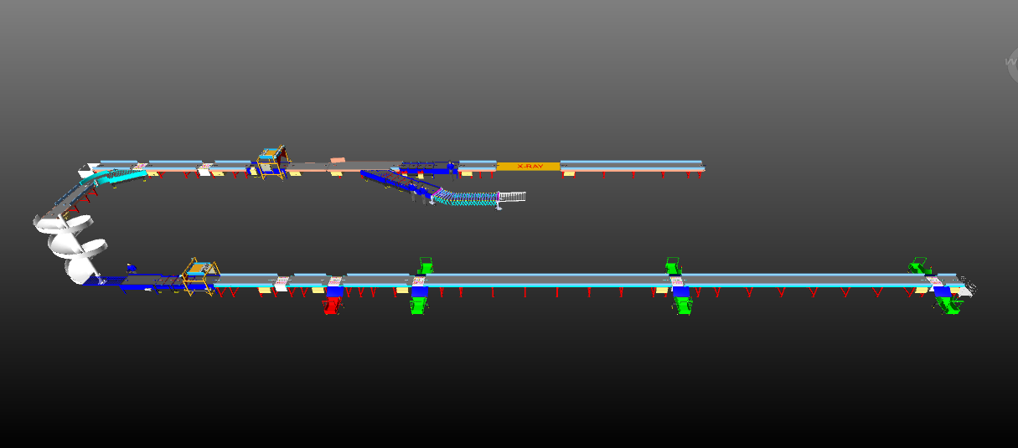

Proposal Reference - F22-00317.02

Falcon Autotech Private Limited
Plot No 308 & 309
Ecotech-1 Extension, Greater Noida
Uttar Pradesh- 201308
India.

Contact – Sanyog Pratap Singh
Assistant Manager
Mob - +91-8750052591
Sanyog.singh@falconautoonline.com

Glossary

S. No. | Term | Description
1 | RFP | Request For Proposal
2 | PPH | Parcels Per Hour
4 | ICR | Intelligent Character Recognition
5 | MEZZ | Mezzanine
8 | AC | Alternating Current
9 | DC | Direct Current
10 | PLC | Programmable Logic Controller
11 | IT | Information Technology
12 | BOQ | Bill Of Quantity
13 | I/O | Input/ Output
14 | PDP | Power Distribution Panel
15 | PC | Personal Computer
16 | UPS | Uninterrupted Power Supply

Executive Summary
Falcon is pleased to confirm its great interest in responding to this Fedex requirement of SWEDI sorter. Our team has been working closely with the relevant stakeholders, with a clear commitment to l istening and understanding your needs and ensuring this project's success.
Following the same objective for the Riyadh system, we are happy to offer a compliant solution meeting all technical and operational requirements, high-performance, optimized, tailor-made, fast and secure planning, and a competitive price.
Our solution is based on the following key characteristics:

- The SWEDI sorter, based on Swivel Wheel Diverting technology, offers a designed throughput of 3,600 pph.
- Two infeed points are included, 02 Automatic barcode scanners, .
- 01 Powered spiral
- 06 Output chutes, 1 rejection chute & 1 Sortfail chute.

A tailor-made and simple layout designed explicitly for Fedex. The proposed layout is the result of the technical requirements in the RFP document and our discussions with the relevant stakeholders during our meeting.

Company Profile
Falcon Autotech (Falcon) is a global intralogistics automation solutions company. With over 10 years of experience, Falcon has worked with some of the most innovative brands in E-Commerce, CEP, Fashion, Food/FMCG, Auto and Pharmaceutical Industries. With our proprietary software and robust hardware integration capabilities, Falcon designs, manufactures, supplies, implements, and maintains world-class warehouse automation systems globally. Falcon’s strong research and development team and the continuous focus on innovation reflect our strong solution line around Sortation, Robotics, Conveying, Vision Systems and IOT. Falcon has done over 1,800 installations across 15 countries on four continents.

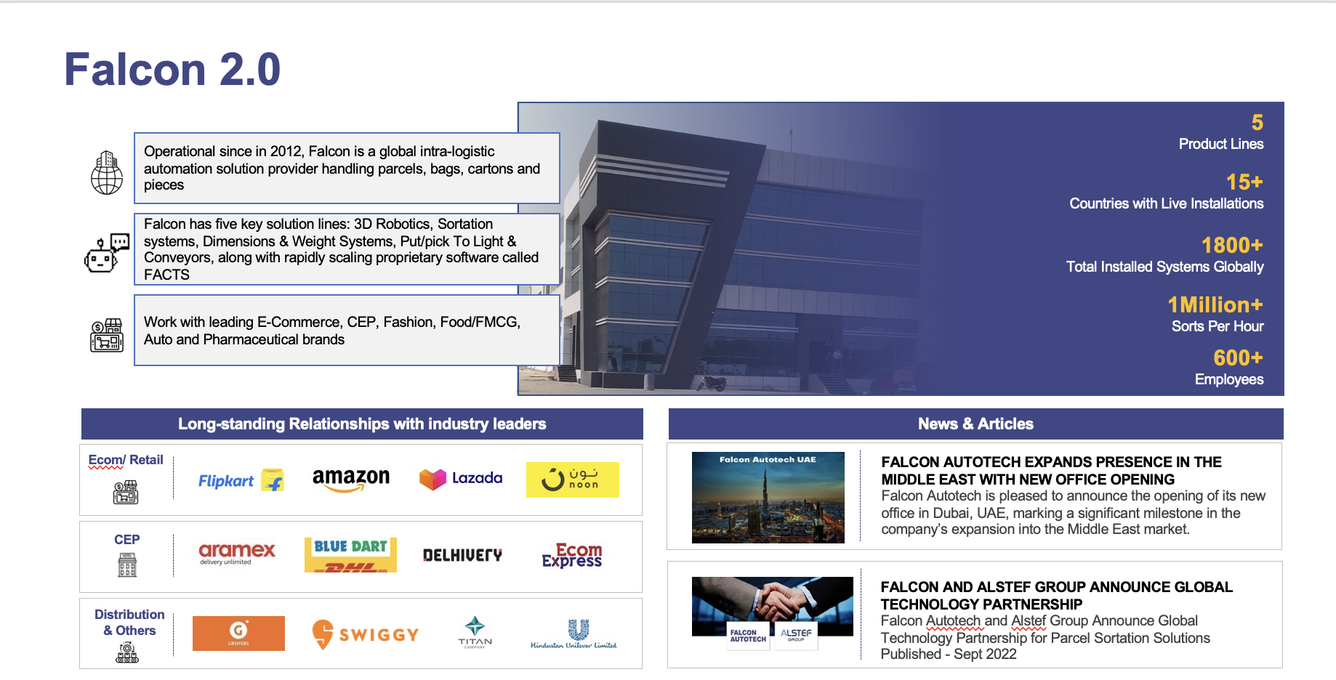

Falcon Autotech is currently among the top 15 intralogistics automation company, our vision is to become top 10 intralogistics automation company in our focused product lines.


The team started out in 2004 solving special purpose automation problems for clients and later established Falcon Autotech in 2012 with strong focus on building standard technology stack spanning across Hardware, Firmware and Software to tackle bigger Supply Chain problems around warehouse automation and material handling. Over the decade, Falcon has made rapid strides and has carved out a niche in some of the world's most cutting-edge technologies: Sortation, Robotics, Conveying, Vision Systems and IOT.
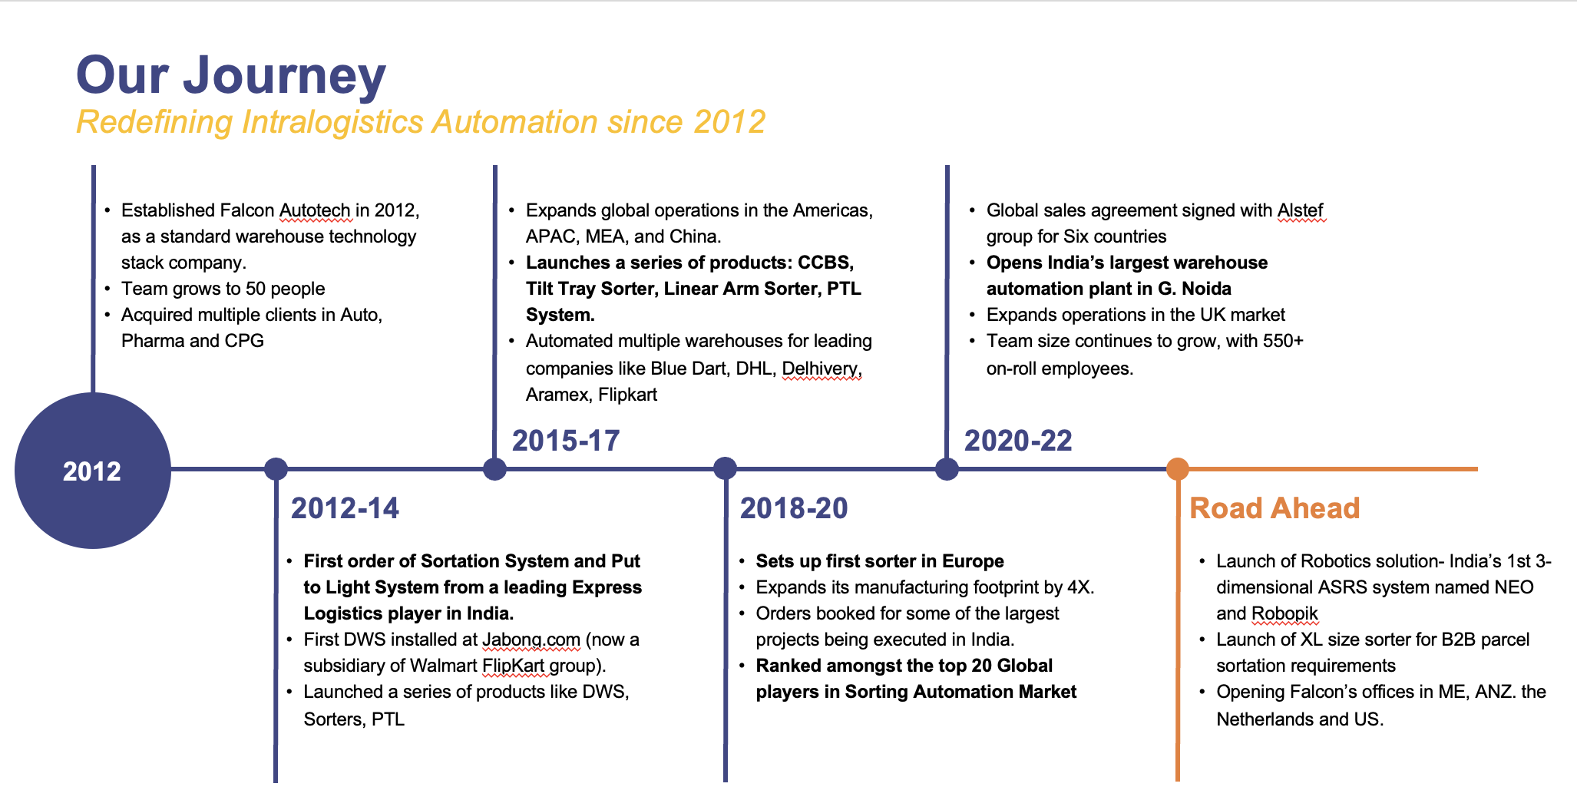
As a leading player in the intra-logistics automation space, Falcon continuously strives to improve the operational efficiencies and accuracies for its clients through its domain knowledge and experience in addition to its wide range of products and solutions. In order to be able to live up to the high expectations set forth by our clients, the team at Falcon realizes the importance of taking up selective applications in focused Industries and deliver world class projects in return.
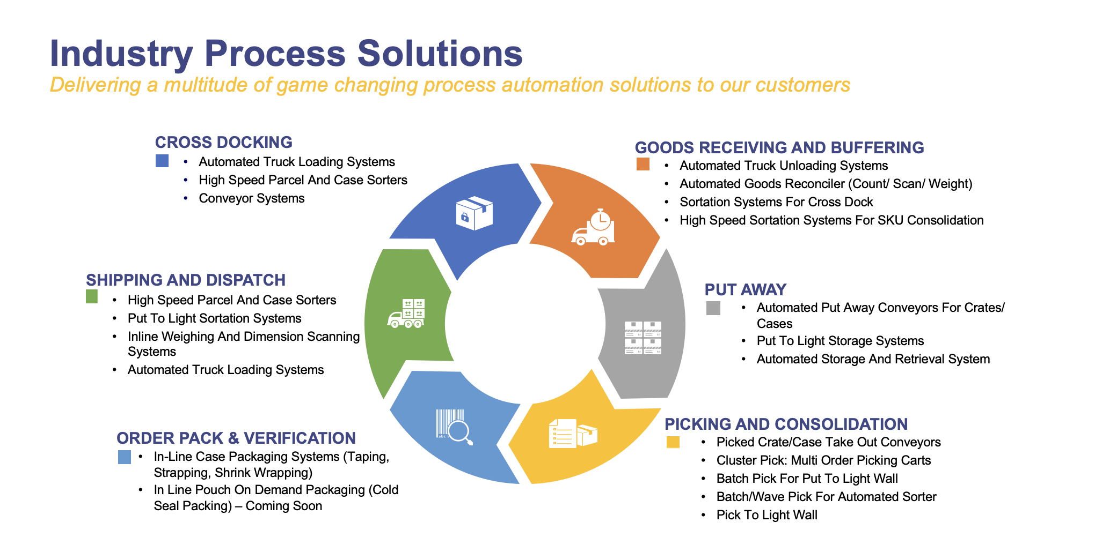

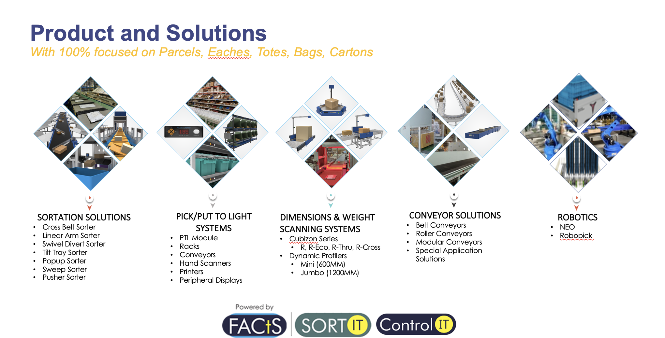
Falcon Autotech has successfully delivered warehouse automation solutions based on smart and innovative combinations of above product lines for effective materials handling, sortation and movement. The process is controlled in real-time by our in house WCS applications. These solutions considerably cut the need for manual operations, improve working conditions and ensure the highest accuracy of the entire process up to final delivery to the recipient.
Over the last 10 years, Falcon has worked with some of the most innovative brands worldwide and has established long standing partnerships. These brands are testimony of our strong focus on delivering superior customer satisfaction and offering end-to-end intralogistics solutions.
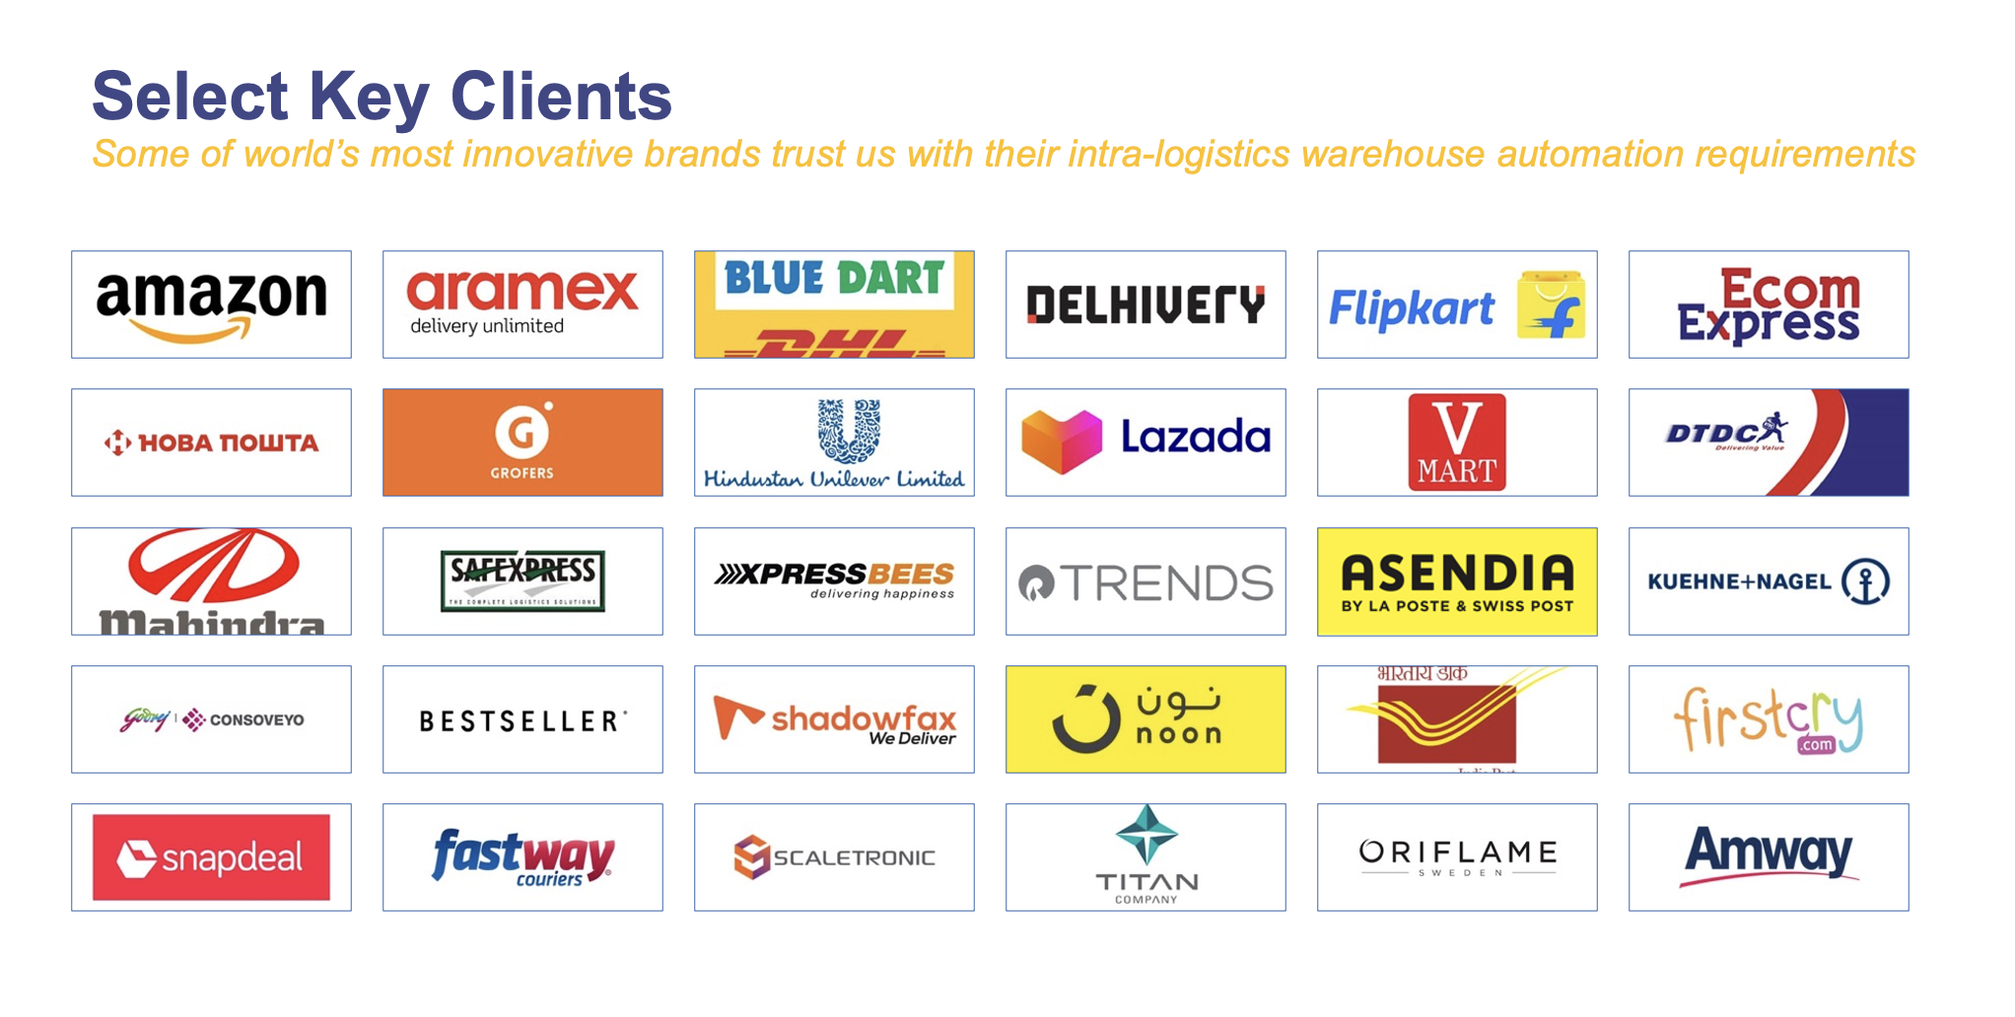

With over 1,800 installations, today Falcon’s systems are used all over the globe. Falcon has highly motivated team of 600+ employees supported by over 15 global partners who help us design, manufacture, deliver and maintain automation solutions globally.
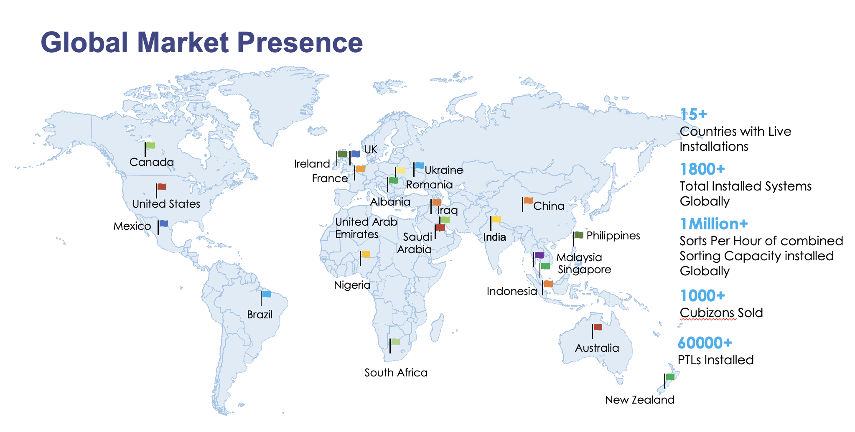

Falcon’s Experience and Achievements in Sortation Space Globally
- Ranked among Top 20 Sortation System Suppliers globally. Only company from APAC/EMEA Region.
- Currently possess one of the World’s largest portfolios in Sortation Technologies: 7 In-house technologies.
- Total installed capacity of 10 million Parcels per day worldwide.
- Only company to be able to offer a Fully Integrated AMS.

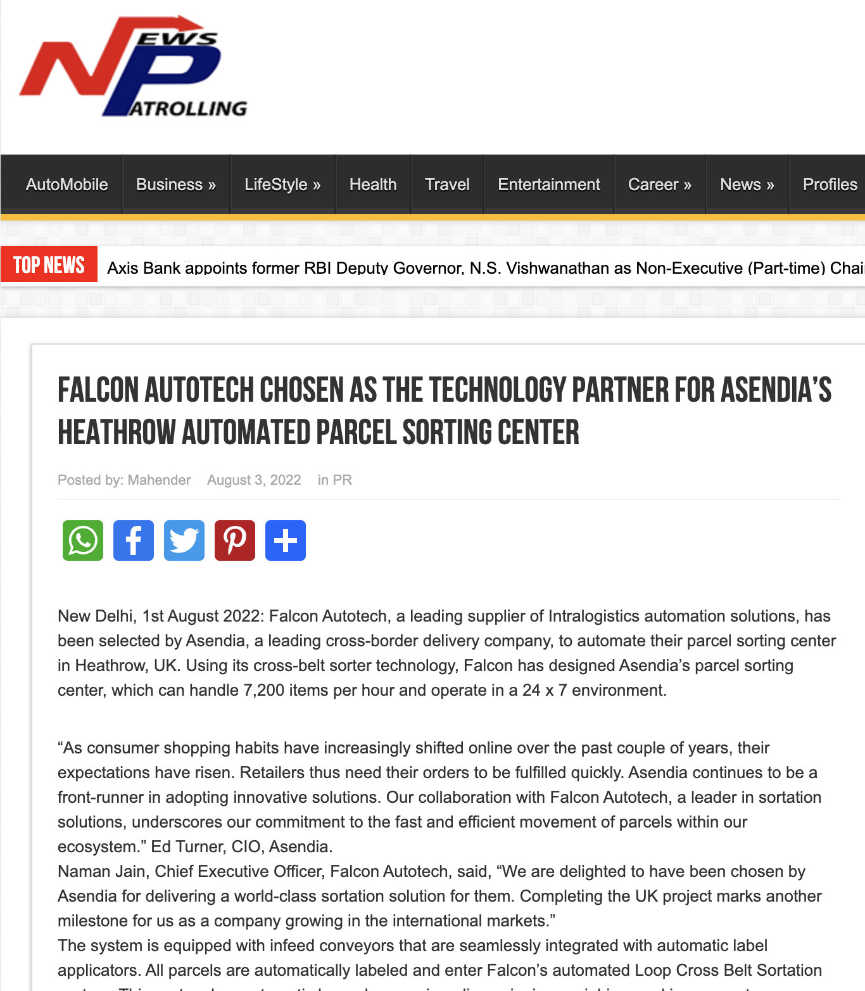




Reference Projects
Falcon has a strong legacy in Warehousing Automation solutions and references-

- Expertise in Parcel Sortation, Piece Picking and Handling, Case Picking and Handling.
- Lifecycle services (maintenance, spares supply chain, support).
- Full in-house expertise (Hardware/Software).
- Turn-key tailored solutions.
The references list presented below focusing on Sortation Solution –

Project 1- (CEP Client, UK)
This Solution is designed to handle a volume of 7200 parcels per hour. The system is equipped with three infeed conveyors integrated with automatic label applicator before parcels enter the sortation system. The parcels are sorted using Falcon's Linear Cross Belt Sorter equipped with automatic barcode scanning, dimensioning, weighing and image capture capabilities. The sorter is installed on the mezzanine floor and sorts directly to 58 end destinations.
Solution Specifications –
- Throughput: 7200 PPH
- End Destinations: 58 Nos
Key Technology Modules –
- Powered Belt Conveyors.
- Automatic Induct Lines.
- Automatic Barcode Scanner with Image Capture.
- Automatic Weight & Volume Measurement System.
- Linear Cross Belt Sorter.
- WCS Software System.
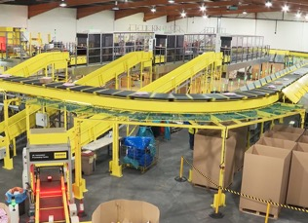
Site Picture –

Project 2- (CEP Client, Riyadh)
In 2019, customer selected Falcon Autotech as a preferred supplier for its airport hub to supply linear cross belt sorter for processing of parcels arriving via Air from different states and countries to distribute them locally. The customer chose Falcon Autotech based on its strong track record of success in providing intralogistics automation solutions, optimized design, software integration capabilities and life cycle support services.
Solution Specifications –
- Throughput: 4800 PPH
- End Destinations: 52 Nos
Key Technology Modules –
- Powered Belt Conveyors.
- Automatic Induct Lines.
- Automatic Barcode Scanner with Image Capture.
- Automatic Weight & Volume Measurement System.
- ARB Conveyor.
- Automatic Label Applicators.
- Linear Cross Belt Sorter.
- Specialized Chutes for Gentle Parcel handling.
- FOCR Engine.
- WCS Software System.
Site Picture –
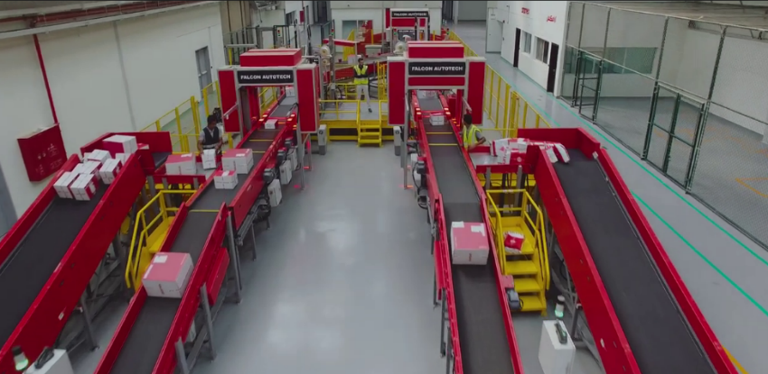

Project 3- (Client – Courier Express Parcel, Dubai & Jeddah)
This Solution is designed to handle the bulk volumes through Launchpads and induct them into Falcon's Linear Arm Sorter. This system is designed for a throughput of 3000 parcels per hour equipped with automatic barcode scanning, dimensioning, weighing and image capture capabilities to into a total of 480 end destinations with a combination of primary and secondary sortation system. The secondary sortation is achieved by integrating put to light system.
Solution Specifications –
- Throughput: 3000 PPH
- End Destinations: 480 Nos
Key Technology Modules –
- Powered Belt Conveyors.
- Linear arm sorter.
- Automatic Barcode Scanner.
- Automatic Weight & Volume Measurement System.
- WCS Software System.
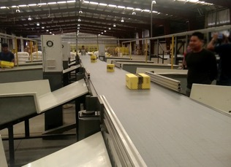
Site Picture –

Project 4- (CEP Client, Sydney)
Solution is designed for handling a throughput of 16,000 parcels per hour with the help of Falcon’s Linear Cross Belt Sorter. The system consists of 2 feeding zones with a total of 10 feedlines. Sorter design enables the van drivers to directly drop the parcels at the dock doors. It has a total of 369 end destinations that are achieved with a combination of direct drops and PTLs. System is integrated with 5 side automatic barcode scanning, weight and volume measurement and automatic detection of oversize and overweight parcels.
Solution Specifications –
- Throughput: 16000 PPH
- End Destinations: 369 Nos
Key Technology Modules –
- Powered Belt Conveyors.
- 2 Induct zone.
- 5 side Automatic Barcode Scanner.
- Automatic Weight & Volume Measurement System.
- Automatic detection of oversize parcel.
- Linear Cross Belt Sorter.
- WCS Software System.
Site Picture –
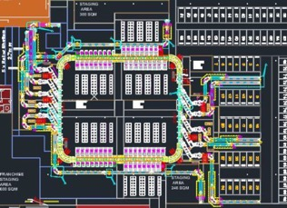

Project 5- (Client – E-Commerce, India)
Use Case – Destination Sorting of Packed Parcels.
In 2019, Client was looking for a potential automation partner for design and development of a new automated sortation system for B2C parcels. The system should be able to provide maximum uptime with reduced dependency on skilled manpower, and space optimization.
The customer chose Falcon Autotech based on its unique design which could cater to all their pain points, capability of seamless integration with WMS and life cycle support services.
Solution Specifications –
- Throughput: 27,600 PPH
- End Destinations: 410 Direct Outputs
- Building Size: 200,000 Sq Ft
Key Technology Modules –
- Bulk Infeed Conveyors.
- ARB based Volume Distribution System
- Integrated Presort System.
- Irregular Ejection System.
- Automatic Induct Lines.
- Automatic Barcode Scanner with Image Capture.
- Automatic Weight & Volume Measurement System.
- Linear Cross Belt Sorter.
- Smart Sliding Chutes for Direct bagging and Cage Sorting.
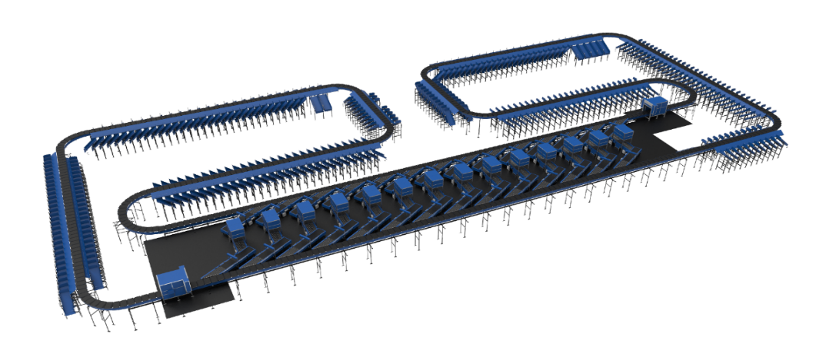
- Bag take out system
- WCS Software System.

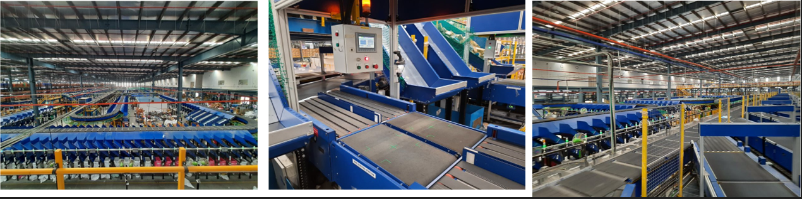

Project 6- (Ecommerce Client, India)
Use Case - Destination Sorting of Packed Shipments
Solution Specifications –
- Throughput: 24,000 PPH
- End Destinations: 110
- Building Size: 200,000 Sq. Ft
Key Technology Modules - Linear Cross Belt Sorter with a cell size of 900 x 500 mm
Layout and Site Pictures -
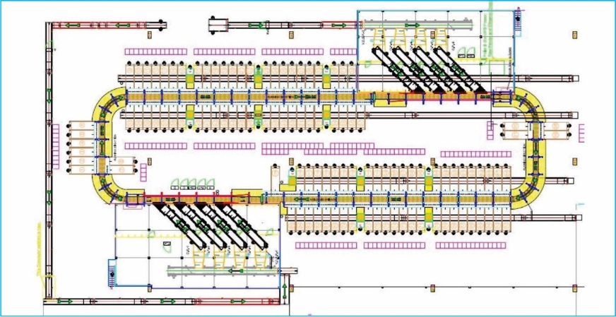
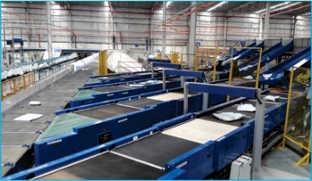

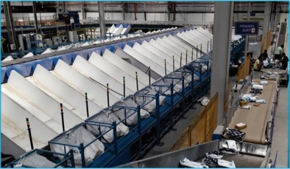

Handled Parcel Spectrum
As per the parcel spectrum data provided in the RFP documents, Falcon has studied and analysed the parcel spectrum in detailed.
Falcon purposes to use its “Single belt Linear Cross Belt Sorter” to provide the maximum benefits to FEDEX in-terms of handling large parcel sizes and weight.

Parcel size loadable on the sorter
Falcon’s SWEDI sorter has a capability to handle the below mentioned parcel sizes and weight.

Specification | Unit | Value
Max Length | mm | 900
Max Width | mm | 500
Max Height | mm | 500
Max Weight | Kg | 35
Min length | mm | 150
Min Width | mm | 150
Min Height | mm | 50
Min Weight | gm | 500

Parcels to be loaded on Sorter shall have the following characteristics:

- Centre of Gravity of item must not move during conveyance or sorting.
- Item must not have magnetic content, otherwise behavior of parcel cannot be guaranteed.
- Liquid or fragile material, to avoid breaking, spillage or leakage, such as wine bottles, metal cans of paint are designated as non- conveyable items.
- Parcels shall be perfectly and safely packaged: protrusion or open surfaces are not allowed.
- Plastic ropes shall be perfectly adherent to the surface of the package.
- All items with the risk of being damaged during the transport on an automatic sorting system or
damaging the sorting system. They must be robust enough to avoid disintegration of container material and loose of contents in the sorting process.
- Item packaging shall have enough grip to be handled on the belts during the acceleration and
referencing phases.
- Items shall not have slippery surfaces and must be able to withstand acceleration of the items on the belt during the start-stop phases (accelerations up to 0.5 g shall be assured without any sliding or tumbling of the items on the belt conveyor).
- The parcels must have at least one flat and regular surface providing enough stability during conveyance.
- All shapes are permitted except spherical, cylindrical, or alike unstable items & shapes.
- All usual packaging materials are permitted (including paper, carton, plastics, plastic foil, rope, tape, textile, and wood)

Parcel not loadable on the sorter

All products that are not within the range as described here, are considered non- conveyable products, and must be taken out of the main sorter flow by the operators.

- Unstable items with a risk to roll or tumble on the sorting system, such as spherical or cylindrical items.
- Items that have a spherical or cylindrical shape.
- Items that are packed in material that can damage the conveyors or the sorter.
- Items that have sharp points (e.g., Nails) or sharp edges, that can damage the conveyors or the sorter.
- Fragile parcels with contents not sufficiently secured.
- Items that have been classified as dangerous are designated.
- Wet items are designated.
- Items with anti-slip treatment.
- Items with protruding parts.
- Items with sharp edges.
- Inadequately packed items that could be damaged during automatic transportation.
- Electrostatically loaded items.
- Loose parts on loads and load carriers, such as adhesive tape, stickers, slips of paper, straps, wrap foil etc. are designated as non- conveyable items.

Pictures of Sortable Parcels
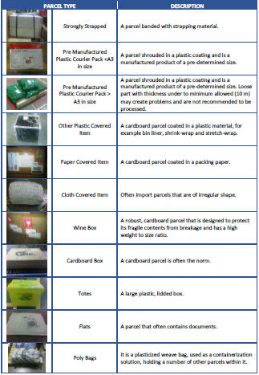

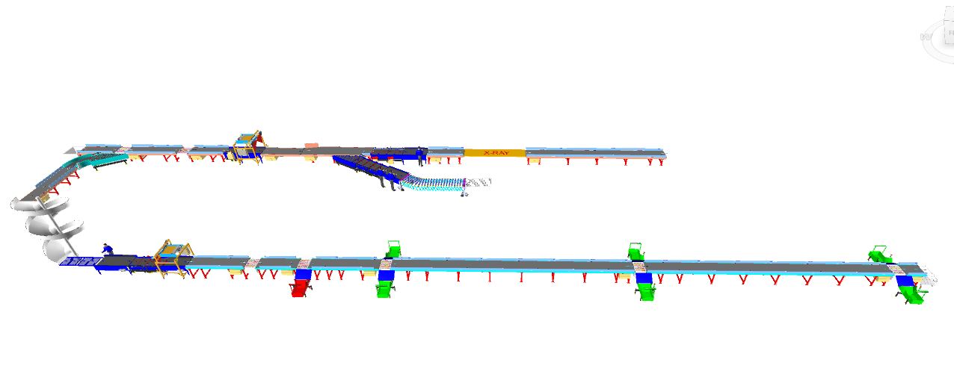
Layout View

Process notes

- Swivel wheel diverter is to be installed at ground floor and the basement.
- The system has 2 infeed points.
- At First Infeed Point:
- Shipments are loaded on to the infeed conveyor in a singulated manner.
- It will pass through the X-ray machine.
- The operator will check the shipments, reject the wrong ones, and orientate the rest in a manner that the bar code is on the top.
- At Second Infeed Point:
  - The pallets are fed into the system.
  - It will pass through the X-ray machine.
  - The operator will bring down the pallet from the conveyor, With the help of pallet handler. break it and fed it to the sorter in a singulater manner ensuring barcode facing top.
  - If the X-ray machine of first infeed will not work, then the shipments will also come from the second (pallet) x-ray machine. These shipments are being transferred from x-ray machine to the feedline through powered flexible roller conveyor.
  - Also, whenever the throughput number high pallet x- ray feedline used for shipment feeding.

- These shipments are then scanned by automatic scanner.
- The first sorting point is at ground floor. Rest of the shipments will be moved to the basement with the help of spiral chute.
- In the basement, there will be an operator who will orientate the shipment and ensure that the barcode is at the top.
- Then these shipments then further scanned by automatic barcode scanner.
- Based on 5 locations, the shipments will be sorted.
- There is rejection chute as well for rejected shipments.

Key Modules

Automatic Feedlines
Fully automatic feedline is used in the system to induct parcels directly on to the sorter

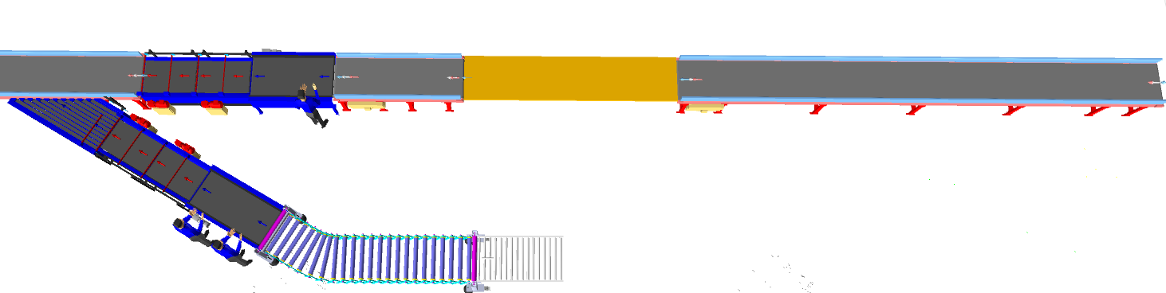

Feedlines consists of below components.

    - Infeed conveyors.
Shipments are loaded on this conveyor in a singulated manner after that it will pass through X- ray machine.
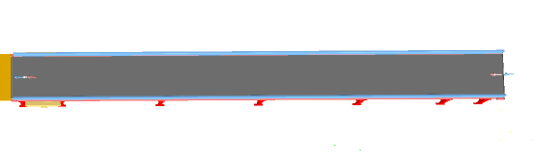

    - Straight and Inclined Powered Belt Conveyor

Falcon’s Belt Conveyors are modular & robust in design, used for smooth conveying of products over Straight, inclined and declined paths. MS profile is used to build conveyor frame.

The conveyors are supplied with the necessary supports and bolts to fix them to the supporting plane, as well as with the junction elements allowing easy and jam-free passage from one conveyor to the other.
Some Silent Features of Falcon’s Belt conveyor:
- Low Noise
- Maximum uptime.
- Minimal maintenance
- High safety standards.
- Fastest ROI.
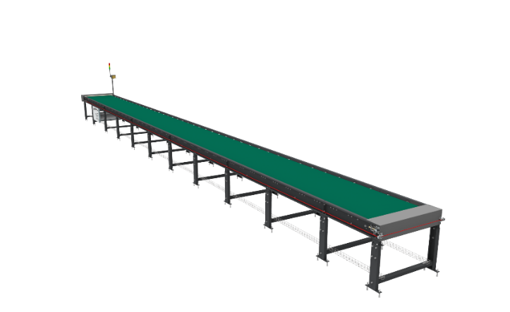

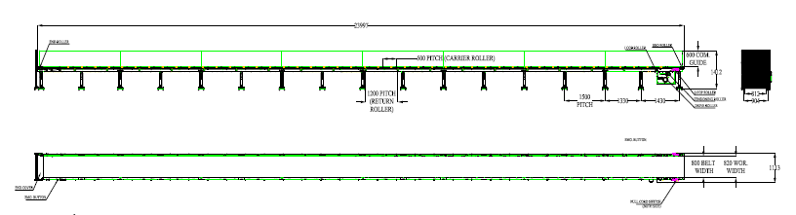

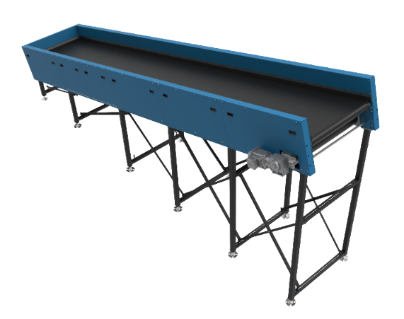
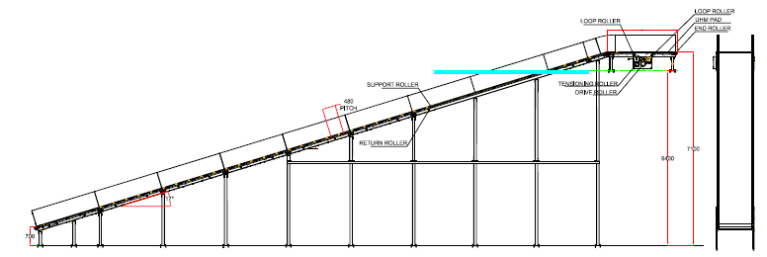

Specification | UOM | Remark
Manufacturer Name | Name | Falcon Autotech
Material of Roller | Type | MS Rollers with Zinc Plating
MOC of Belt | Type | PVC
Belt Thickness | mm | 3
Belt Finish | Type | Matt Finish
Belt width | mm | 1000
Belt Joint Type | Type | Vulcanized, Endless Belts
Belt Make/Model No. | Make | FORBO/DERCO
Chassis | mm | MS, 3mm Thick, Powder Coated-75 Microns
Idler Roller Pitch on running side (Top) | mm | 480
Idler Roller Specs | Spec | Dia.50.8, shaft-12 mm, bearing-6301
End Rollers | Spec | Dia 81.2 x 2.85 Thick, 30mm Shaft Dia, & Bearing Size-UCFH206D1, MOC-EN9, Zinc Plated -25 microns
Drive Rollers | Spec | OUTER Dia 178 PIPE Dia 168x5 Thick, 40mm Shaft Dia, & Bearing Size-UCF208D1, MOC(SHAFT)-EN9, NEOPRENE RUBBER COATING
Motor Shaft | MOC | EN9 Shaft material
Conveyor Under guarding | Spec | MOC-MS, 0.8 to 1mm thickness, Steel Stiffeners at every 600mm to avoid the sagging due to self-weight
Load capacity per unit length of Conveyor | kg/m | 50
Type of Guides | Type | Steel guides at 50mm/400mm height basis the position of conveyor on both sides from Conveyor Belt Surface.
Drive Power Rating | kW | Motor Rating depends on Length of the Conveyor
Type of Motor | Type | AC Geared Motor
Ingress Protection | Type | IP 55
Type of Drive System | Type | Direct Shaft Mounted Motor/ Flange Mounted
Type of Drive | Type | Chain drive/Torque Arm type
Gear Motor | make | Sew/Nord
Drive | make | Lenze/Siemens/Omron/Allen Bradly
Insulation Class | Type | Yes
Conveyor Speed | m/s | Variable speed to meet TPH requirements
Type of Mounts | Type | Fixed Heights Legs with Grouting Provisions

    - Plastic Modular Belt Conveyor

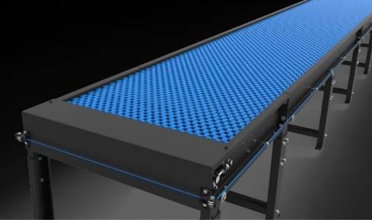
Falcon’s Belt Conveyors are modular & robust in design. MS profile is used to build conveyor frame.
Some Salient Features of Falcon’s Modular Belt conveyor:
- Low Noise
- Maximum uptime.
- Minimal maintenance
- High safety standards.
- Fastest ROI.
Specification | UOM | Remark
Manufacturer Name | Name | Falcon Autotech
Plastic Modular Belt Material | Type | POM with PBT Pins, Pitch-25.4 mm, Pin Dia- 5mm
Plastic modular Belt Make | Make | Movex
Sprocket Size & No. of Sprockets on Drive End & Tail End | Type | 5/146.4 mm
Sprocket material | MOC | POM
Chassis | mm | MS, 3mm Thick, Powder Coated-75 Microns
Wear Strip Material | MOC | UHMW PE1000
Return Roller type | Type | DIA- 50 mm/20303
Return Roller Pitch | mm | 800
Driven Shaft | Type | MOC-EN9 Solid Shaft hardened to BHN 240, Size-60SQ MM, Zinc Plated -25 microns, Bearings-UCF-210D1
Duplex Sprocket | MOC | MS
Duplex Chain | MOC | MS
Conveyor Under guarding | Type | GI SHEET (1MM THICK)
Type of Guides | Type | Steel guides at 50mm/400mm height basis the position of conveyor on both sides from Conveyor Belt Surface.

    - Idler Roller Conveyor
Falcon’s Roller conveyors require negligible maintenance leading to very minimal Operating costs and thus lower cost of ownership.
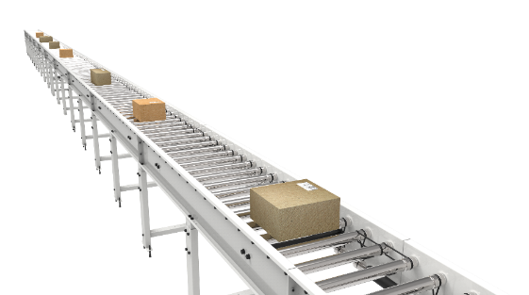
Some Salient Features of Falcon’s idler roller conveyor:
- Low Noise
- Maximum uptime.
- Minimal maintenance
- Comes with MS frame.

Specification | UOM | Remark
Manufacturer Name | Name | Falcon Autotech
Material of Roller | Type | MS Rollers with Zinc Plating
Overall Width | mm | 1000
Conveyor Height | mm | As per Layout requirement
Load capacity per unit length of Conveyor | kg/m | 50
Roller Span | mm | approx. 600
Roller Diameter | mm | approx. 50
Pitch of Rollers | mm | 75
Type of Mounts | Type | Fixed Heights Legs with Grouting Provisions
Type of Guides | Type | Yes
End Stopper | yes/no | Yes

    - Shipment Loading Conveyor
It’s a approx. 2.5 m long. Powered Belt Conveyor for Shipment Loading. It is running at approx. 800 mm from ground Level.
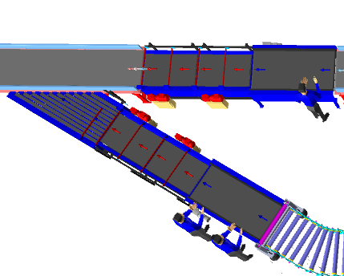
    - Detachable flexible conveyor.
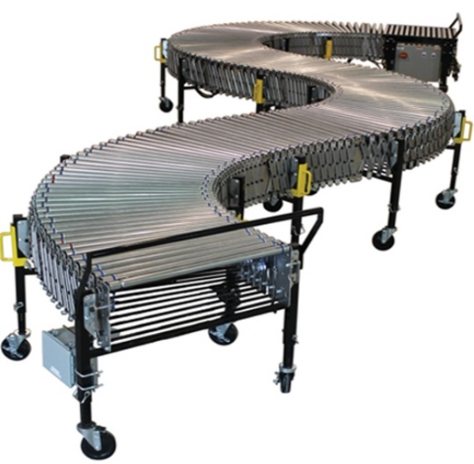
Flexible conveyors are used to load and unload the shipments from truck. It let you change discharge points by rolling and curving conveyor sections to fit your needs. They're commonly used at shipping docks or the discharge end of a conveyor system to connect to truck trailers. A single conveyor can serve multiple dock doors.

S. No | Description of Goods | Details
1 | Conveyor Width Between Frame | 800mm
2 | Conveyor Open Length | 10000mm
3 | Conveyor Closed Length | 5000mm
4 | Roller Close Pitch | 60mm
5 | Roller Open Pitch | 120mm
6 | Adjustable Height | 950 - 1200mm

    - Orientation Conveyor.

It’s a approx. 6 m long. Powered Belt Conveyor for Shipment Orientation running at approx. 800 mm from ground Level.

    - Spacing Conveyor
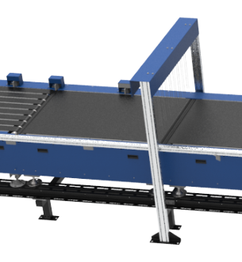
It’s a Special Conveyor, used to create space between parcels

    - Buffer conveyor
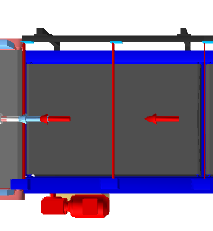
High-speed conveyor, used to create appropriate space between parcels/boxes and synchronize the infeed into the Sorter.

    - Intelligent merge / Angle merge.
This is 30° triangular Dual Belt high-speed conveyor used for inducting parcel/boxes directly on to the sorter. The Belts are Strip Belts for smooth parcel movement.

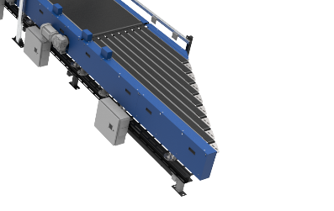
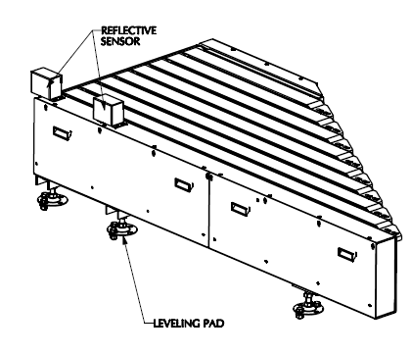

    - Spiral chute.
The Spiral chute is a compact and versatile elevating solution. It is specially designed chute which will take the shipments from G0 to Basement.

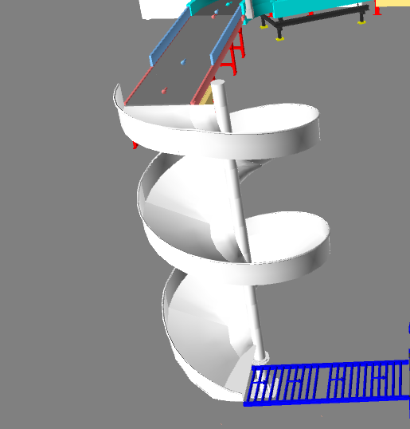

  - Barcode Scanning

    - Automatic Barcode Scanning
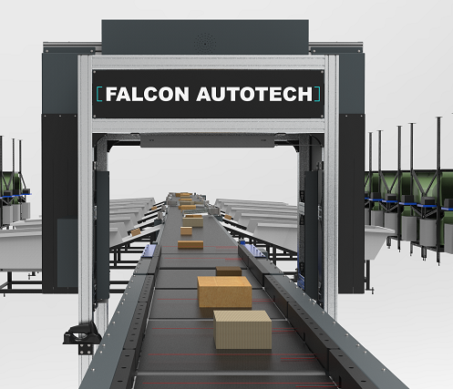
System is Integrated with Automated Line Scan Camera Technology (Sick ICR) for scanning 1D & 2D Barcodes.

Specification | UOM | Remark
Manufacturer Name | Name | Cognex
Barcode Type | Type | 1D & 2D
Module Size | Mils | X or higher
Shipment Size | Mm | Min: 150 x 150 x 5  Max: 900 x500 x 500
Number of Codes | Nos | 1
Location | Side | Top
Orientation | Type | Top side
Color of bars | Color | Black
VMS | Nos | 1
Under Foil | yes/no | No

    - Handheld barcode Scanner
System is equipped with handheld barcode scanners capable for scanning 1D barcodes for Semi Auto mode.
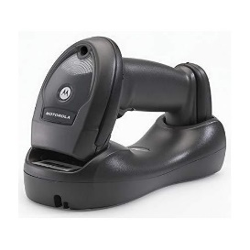

  - Sorter: Swivel Wheel Divert
Swivel Wheel Diverter (SWEDI) is a non-impact sortation module for linear sortation lines, ideal for medium volume sort centres. SWEDI's modular design allows it to save space while also allowing for future expansion of sorting point
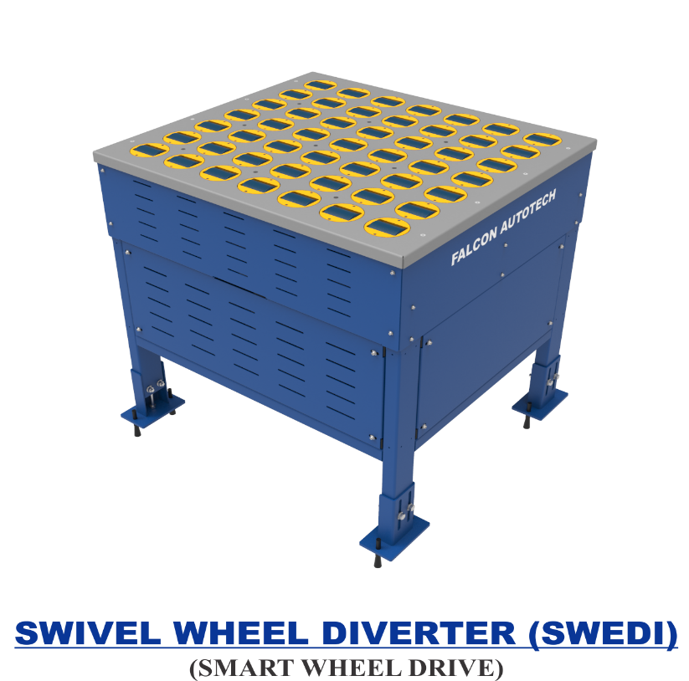

Technical specifications of SWEDI Unit
Items | Make
SWEDI Unit’s Dimensions | 815 mm (L) x 915 mm (W)
Load Capacity | 35 KG
Throughput (Upper deck) (Future) | 3600 PPH
Conveying Drive Unit | 48V, 50 Watt DC powered smart roller
Diverting Drive Unit | Servo Motor; 220V, 50HZ, 750W, Single Phase
Conveying Speed | Up to 120 m/min
Diverting Angle | 90 Degrees at double sides
Frame Material | MS Powder Coated Steel Frame
Stand Support | MS Powder Coated Steel Frame
PLC | Siemens
Servo Motor | Delta
Noise Level | <75 Db when measured from 1 m in a silent warehouse.

  - Sliding Chutes
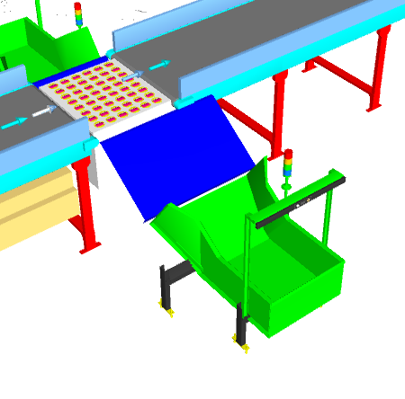
Parcels are collected in the in trolley with the help of sliding chute. The chutes are equipped with Chute full sensors and tower lamps.


  - Steel works.
Platform 3 SQM (Approximately).

Key Component Makes
S. No. | Description | Makes
1 | PLC | Siemen's
2 | HMI | Siemen's
3 | Control Cabinet & Accessories | BCH / Rittal
4 | Drives | Allen Bradely/ Lenze/ Siemen's
5 | Drive Motor and Gearbox | SEW/ Bonfigloili
6 | Sensors | Sick, P&F
7 | Bearings | SKF, NBC, NTN
8 | PVC Belt | Forbo, Derko,
9 | Rollers Make | Pulse/ Falcon
10 | Automatic Barcode Scanners | SICK/ Cognex
11 | Handheld Scanners | Motorola/ Honeywell

Proposed System Technical Details.

Mechanics
Pos. | Qty. | Description | Value
FM1 | 1 | Conveyor Automation
 |  | 02 x Angle merge.  13 x Powered Belt Conveyor; L-82.5m  02 x Scanning Conveyor; L-4m  03 x Spacing Conveyor  03 x Short Buffer Conveyor  03 x Receiving Conveyor  01 x 60-degree merge  01 x Detachable flexible conveyor L- 10m  01 x Modular Conveyor; L- 5.7 m;  03 x Powered Roller Conveyor; L-4.8m | Width-1000 mm
FM2 | 1 | Falcon Sorter-Swivel Wheel Diverter
 |  | System Width | 915 mm
 |  | System Length | 815 mm
 |  | 1 x Automatic Barcode Scanning System.
07 X Swivel Wheel Divert Units.
07 X Collection chute.
01 X Spiral chute
01 X Rejection trolley
01 X Portable Bin

Controls
FC1 | 1 | Controls, IT and Wiring
 |  | Software Package
 |  | Control Panels
 |  | Sorter Control | Included
 |  | Electrical & Control Hardware
 |  | Switches
 |  | Drive panels
 |  | Operator Panels
 |  | Internal & Field Wiring

Price Schedule

Price Sheet for Linear CBS

Below chapter consists of Price of Falcon’s Mechanics and Controls.

S. No. | Description | Price (USD)
1 | Feedline and Sorter | $ 287,869
2 | Conveyors | $ 168,159
3 | Chutes | $ 5,901
4 | Controls, IT and Wiring | $ 8,684
5 | Tool Kit | $ 1,155
6 | Project Management and Engineering Charges | $ 12,385
7 | Packaging & forwarding | $ 23,178
8 | Steelwork | $ 470
Total (USD) Excluding Taxes. |  | $ 507,802
9 | Discount | $ 25,390
Grand Total (USD) Excluding Taxes. |  | $ 482,412

Total Price is to be understood-
- Including Packing & Forwarding Charges
- Excluding Installation & Commissioning Charges
- Freight- Excluded
- Taxes Extra as applicable
- Unloading in Client’s Scope
- Laydown Area to be provided by FedEx.

Payment Terms.
The Supplier Quotation is based on the following payment schedule:
Payment %age | Project Stage
50 % | Advance
20 % | When material is ready for dispatch
10 % | After material reaches site
10 % | Against mechanical & Electrical installation
10 % | Against commissioning & handover

Delivery Schedule

22 to 24 weeks Ex-Works, Greater Noida from the date of PO, full payment, and DAP

Warranty Period
Falcons offered System comes with a standard warranty of 2 year (Starts from the date of beneficiary use) and post completion of warranty, customer can opt for an Extended warranty. The warranty covers the following support:
- 24 X 7 Telephonic, Email and Remote Service Support when required.
- Regular Software updates and Bug Fixes.
- Supply of Mechanical and Electrical components in case of failure (excluding damages as mentioned in the Exclusion Clause)
The warranty does not apply to the replacement or repair of:
- Normal wear and tear.
- Consumables.
- Faulty articles continued:
  - Failure to comply with the manufacturer's recommendations (logistics documentation, Technical Information Note, retrofit document) and the rules of the trade.
  - Negligence or abnormal use of equipment.
  - Anomalies produced by an environment of use, storage or transport that does not comply with the specifications or recommendations of Falcon: packaging, temperature, hygrometry, sector, insulation, etc.
  - A defect due to a cause external to the supplies and services of Falcon.
- Equipment other than that supplied by Falcon.
- Items that can be repaired exclusively by Falcon that have been repaired or attempted repairs other than those carried out by Falcon.
- Items that fail due to normal wear and tear of one or more of its components or whose tamper-evident seals (varnish, strip, etc.) have been broken or whose serial numbers have been removed or modified.
- Items damaged during transport to Falcon due to the use of unsuitable packaging.

Exclusions
The scope of supply includes all parts which are defined in the Supplier’s quotation.
All other parts which are not defined in the Supplier’s quotation do not belong to the Supplier’s scope of supply and are excluded. The following parts are also excluded:

- Server PC & Server Rack
- Excluding installation and Commissioning
- Construction Power
- Steel Works- If not specified
- Collection Bin
- Building infrastructure; building structure, doors, fire exits, levelling devices, building extinguisher and fire alarm system, building heating and lighting system.
- Electrical power supply and wiring to the main control cabinets
- UPS for Controls and Drives
- Electrical Power for Installation
- Network Cabling up to the Main Server Rack
- Intermediate wiring to parts which are to be supplied by the Purchaser/others
- Emergency/Uninterruptable power supply
- Fire-alarm and fire protection devices
- Traffic and route markings
- Laydown Area
- Ram protection devices
- Cat walks, bridges, maintenance aisles and platforms
- Assembly tools like forklifts and hoisting machines
- All kind of network incl. Local Area Network (LAN/WLAN), exceeding the scope described in Scope of Supply
- Any Kind of Civil work
- Any adjustment of the Supplier’s scope of supply to local rules and regulations
- X-Ray machines
- Roller cages/ Pallets
- Simulation and 3D animation of the sorter system
- Interface with other equipment not specified in this offer.
- Provision of facilities for the control room (furniture, air conditioning, heating, etc.).
- The supply and installation of fencing around the different corridors.
- Any item specifically indicated as not forming part of the subject matter of the Seller's supply in the offer documentation.

